**RAJALAKSHMI ENGINEERING COLLEGE**

**RAJALAKSHMI NAGAR, THANDALAM – 602 105**



|  |
| --- |
| **CS23A34**  **USER INTERFACE AND DESIGN LAB** |
| **Laboratory Observation Notebook** |

# Name : SKANDAN KAMAL

# year/Branch/Section : II/CSE/C

# Register No. : 230701322 Semester : IV Academic Year: 2024-25

**Ex. No.: 8.a**

**Register No.: 230701322**   **Name: SKANDAN KAMAL**

**Create storyboards to represent the user flow for a mobile app (e.g.,**

**food delivery app) using Balsamiq**

**AIM:**

The aim is to create storyboards representing the user flow for a mobile app, such as a food delivery app, using Balsamiq.

**PROCEDURE:**

**Tool Link: https://balsamiq.com/**

**Step 1: Define the User Flow**

1. **Identify Key Screens**:
   1. List the main screens your app will have (e.g., Home, Menu, Cart, Checkout, Order Confirmation).
2. **Map the User Journey**:
   1. Understand the typical user journey through these screens (e.g., browsing menu, adding items to cart, checking out).

**Step 2: Create Storyboards Using Balsamiq**

1. **Install Balsamiq**:

○ Download and install Balsamiq from the https://balsamiq.com/ website.

1. **Create a New Project**:

○ Open Balsamiq and create a new project.

1. **Add Wireframe Screens**:
   1. Use the “+” button to add new wireframe screens for each key screen in your app.
2. **Design Each Screen**:
   1. Use Balsamiq's components to design the UI for each screen.

○ Include basic elements like buttons, text fields, and images.

1. **Organize the Flow**:
   1. Arrange the screens in the order users will navigate through them.

○ Connect the screens with arrows to represent user actions.

**Example Screens for Food Delivery App**

1. **Home Screen**:
   1. Search bar for finding restaurants

○ Categories for different cuisines

1. **Menu Screen**:
   1. List of food items with images, names, and prices

○ Add to Cart buttons

1. **Cart Screen**:
   1. Items added to the cart with quantity and total price

○ Checkout button

1. **Checkout Screen**:
   1. Delivery address form

○ Payment options

○ Place Order button

1. **Order Confirmation Screen**:
   1. Order summary

○ Estimated delivery time

**Example Output**

Here's how the wireframes might look: **Home Screen**

* **Search Bar**: Allows users to search for restaurants.
* **Categories**: Buttons for different cuisines (e.g., Italian, Chinese).

**Menu Screen**

* **Food Items List**: Displays food items with images, names, and prices.
* **Add to Cart**: Button to add items to the cart.

**Cart Screen**

* **Items Added**: Lists items added to the cart with quantity and prices.
* **Checkout Button**: Proceed to checkout.

**Checkout Screen**

* **Delivery Address Form**: Users enter their delivery address.
* **Payment Options**: Choose between different payment methods.
* **Place Order Button**: Finalize the order.

**Order Confirmation Screen**

* **Order Summary**: Shows the order details.
* **Estimated Delivery Time**: Provides an estimated delivery time.

**OUTPUT:**

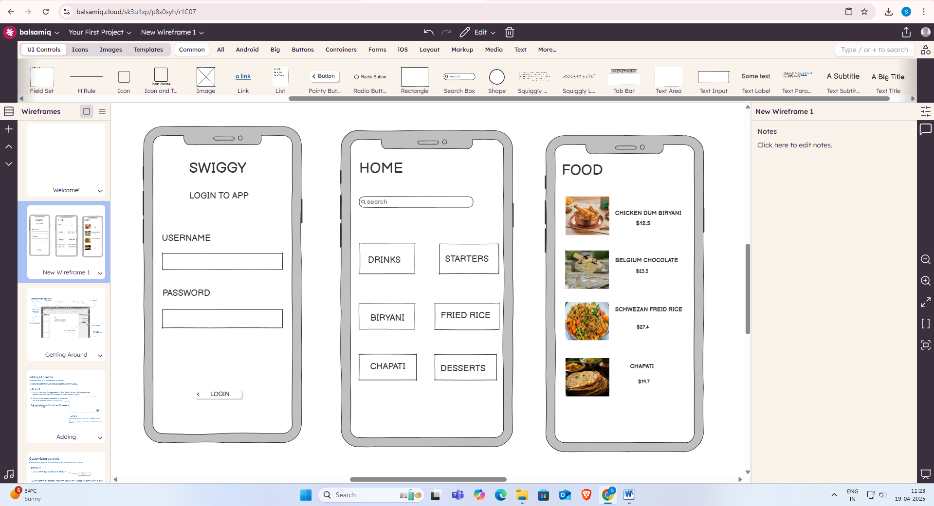

**RESULT:**

Hence we have created storyboards representing the user flow for a mobile app, such as a food delivery app, using Balsamiq.